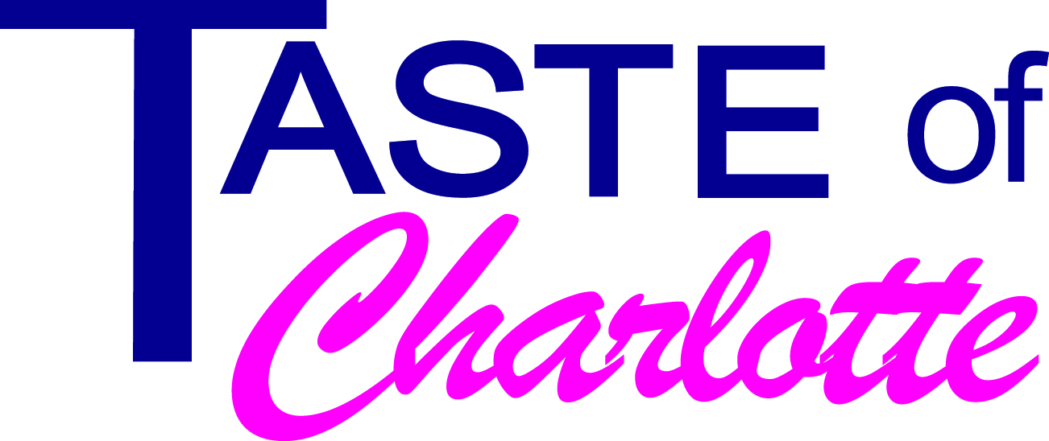
For More Information Contact:
Carrie Griffin
carrie@tasteofcharlotte.com
704.572.9870
June 3, 2016

Media Advisory

Tastiest 5K in Charlotte Returns June 11th

Who: Taste of Charlotte Festival

What: Race to the Taste, 5K and Cupcake Run/Walk

When: Saturday, June 11 at 9:00am

Where: Uptown Charlotte, Starting on Trade Street between Tryon and Church

Taste of Charlotte is excited to bring back the Race to the Taste 5K and Cupcake Run/ Walk this Saturday. Both will start and end at the Taste of Charlotte on the Saturday of the 3 day festival. Registration is still available at: https://www.sportoften.com/event/17743/race-to-the-taste-5k

The 5K, Race to the Taste will start at 9:00am. The race course will follow the city streets Uptown and in to Southend for a beautiful skyline view. After runners finish the race, they can join the after party with live steel drums playing in the Tavern at the Taste from Minsky Delmonte. Runners will receive an awesome swag bag with a ticket to a Charlotte Checkers game plus a Super Coin to be used on a restaurant sample at Taste of Charlotte!

Soon after the 5K ends, the Cupcake Run/ Walk will take off. Participants can race around the event site, grabbing cupcakes along the route or they can take it slow and walk it while savoring their dessert!

The inaugural race in 2014 brought over 500 runners and over 1500 cupcakes! For the third year, Taste of Charlotte has partnered with the Charlotte Checkers Foundation. The Checkers will be onsite with Chubby Checker and the Checkmates to help cheer on the runners. A donation will be made to the Charlotte Checkers Charitable Foundation from the proceeds of the Race!

Taste of Charlotte, is a 3 day food and entertainment festival June 10th – 12th. Over 100 restaurant samples, live entertainment, unique shopping and children’s activities line Tryon Street from Stonewall to Trade. For more information about the festival, visit www.TasteofCharlotte.com and look for us on Facebook –

